# Multidimensional Arrays – Lab

This document defines the exercises for the ["C++ Advanced" course @ Software University](https://softuni.bg/trainings/3658/cpp-advanced-may-2022). Please submit your solutions (source code) to all below-described problems in [Judge](https://judge.softuni.org/Contests/3033/CPlusPlus-Multidimensional-Arrays-Lab).

Write C++ code for solving the tasks on the following pages.

Code should compile under the C++03 or the C++11 standard.

## Sum Matrix Columns

Write a program that **read a matrix** from the console and prints the sum for each column. On the first line, you will get matrix **rows**. On the next **rows** lines, you will get elements for each column separated with a space.

### Examples

|  |  |
| --- | --- |
| **Input** | **Output** |
| 3 6  7 1 3 3 2 1  1 3 9 8 5 6  4 6 7 9 1 0 | 12  10  19  20  8  7 |
| 3 3  1 2 3  4 5 6  7 8 9 | 12  15  18 |

## Primary Diagonal

Write a program that finds the **sum of the matrix primary diagonal**.

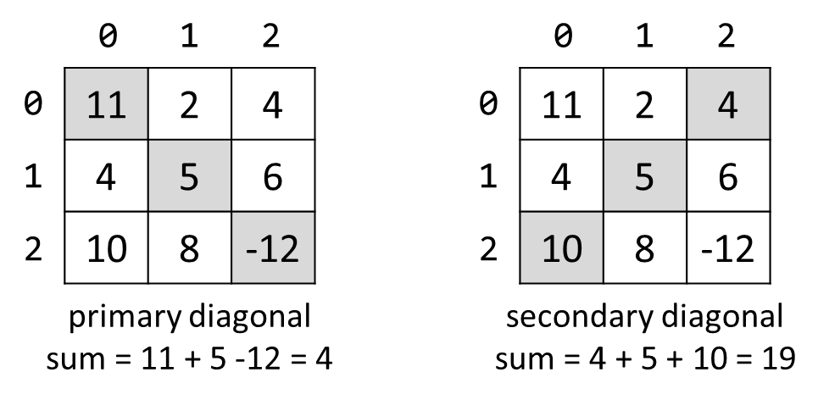

### Input

* On the **first line**, you are given the integer **N** – the size of the square matrix.
* The next N **lines** hold the values for **every row** – N numbers separated by a space.

### Examples

|  |  |
| --- | --- |
| **Input** | **Output** |
| 3  11 2 4  4 5 6  10 8 -12 | 4 |
| 3  1 2 3  4 5 6  7 8 9 | 15 |

## Symbol in Matrix

Write a program that reads **N**, a number representing **rows** and **cols** of a **matrix**. On the next **N** lines, you will receive rows of the matrix. Each row consists of ASCII characters. After that, you will receive a symbol. Find the **first occurrence** of that symbol in the matrix and print its position in the format: "({row}, {col})". If there is no such symbol print an error message: "{symbol} does not occur in the matrix ".

### Examples

|  |  |
| --- | --- |
| **Input** | **Output** |
| 3  ABC  DEF  X!@  ! | (2, 1) |
| 4  asdd  xczc  qwee  qefw  4 | 4 does not occur in the matrix |

## Diagonal Difference

Write a program that finds the **difference between the sums of the square matrix diagonals** (absolute value).



### Input

* On the **first line**, you are given the integer **N** – the size of the square matrix.
* The next N **lines** hold the values for **every row** – N numbers separated by a space.

### Output

* Print **the absolute** difference between **the sums** of the primary and the secondary diagonal.

### Examples

|  |  |  |
| --- | --- | --- |
| **Input** | **Output** | **Comments** |
| 3  11 2 4  4 5 6  10 8 -12 | 15 | **Primary diagonal:** sum = 11 + 5 + (-12) = 4  **Secondary diagonal:** sum = 4 + 5 + 10 = 19  **Difference:** |4 - 19| = 15 |